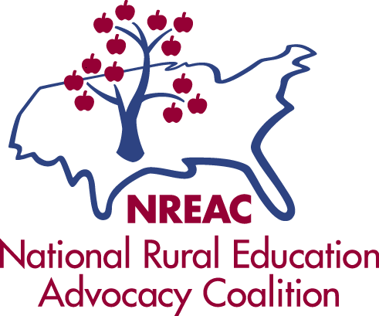
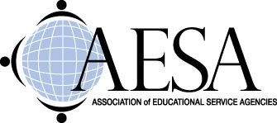

Senator James Inhofe
United States Senate
Washington, DC 20515

Senator Barbara Boxer
United States Senate
Washington, DC 20515

September 6, 2016

Dear Senators Inhofe and Boxer,

On behalf of AASA, The School Superintendents Association, the Association of School Business Officials International, the Association of Educational Service Agencies, the National Rural Education Association, and the National Rural Education Advocacy Coalition, we write to express our support for an amendment being considered in the broader legislative proposal to reauthorize the Water Resources Development Act. While we are not taking a position on the reauthorization as a whole, we do support the amendment put forward by Senator Booker to address lead in school water. Given the news coming out of Flint (MI), Newark (NJ), and other communities across the country, this amendment, if adopted and properly funded, is a crucial step in protecting children from harmful contaminants.

Collectively, our organizations (AASA, ASBO, AESA, NREA and NREAC) represent public school superintendents, school business officials, school system and educational service agency leaders, and rural educators, including parents, teachers, and administrators. We understand that keeping our students safe is critical to our jobs as educators, and this amendment provides the resources we need to do so.

Many school leaders are already taking steps to test school water and remedy any issues found, but with tight school budgets and other pressing issues, it is difficult to ensure the safety of all students. This amendment would require water utilities to add schools to the list of buildings they are already testing and would introduce a grant program to reimburse schools for any costs incurred in addressing any lead-related issues that exist. Since water utilities are already testing homes throughout the community they serve, this amendment would have minimal impact on the water utility while providing a crucial service to schools and the students they serve.

School leaders are committed to ensuring the safety of the water in their schools and many are already addressing lead-related issues in their schools. All too often, though, finding the funding for lead abatement requires a sacrifice as school budgets remain below pre-recession levels and are stretched very thin. The grant program in this amendment would help alleviate this burden and allow any school leader to replace any lead-containing water fixture and keep our students safe. We support this amendment and will advocate to support adequate appropriations.

We look forward to working with you on this issue.
Sincerely,

Leslie Finnan
Senior Legislative Analyst
AASA, The School Superintendents Association

