Myth versus Fact on
Federal Funding for Education
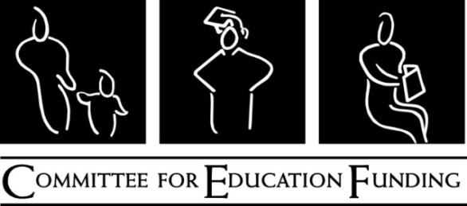
February 6, 2017

Myth: The U.S. education system is flush with cash but leaves students deprived of knowledge.
- Fact: Education funding for elementary and secondary education – both from the federal government and from about half the states – is less than it was ten years ago.
Current federal K-12 funding is still below the 2008 level even though public school enrollment has increased by 2.3 percent over those ten years. In addition, 23 states are on track to provide less formula funding in 2017 than they did ten years ago, cutting the largest source of support for elementary and secondary education.
Myth: Federal education funding has grown out of control.
- Fact: Education spending accounts for 2% of the federal budget, and has for decades.
Not only is federal support for K-12 education programs below the level it was 10 years ago, total federal education spending has hovered at about 2% of the federal budget for that period, ranging from a low of 1.2% in 2013 to a high of 2.7% in 2010, when education funds under the Recovery Act were spending out. Those percentages haven’t changed significantly for decades.
Myth: Money doesn’t matter in education.
- Fact: Increased funding can and does boost student achievement.
Not surprisingly, spending more to train teachers, lower class size, provide safe learning environments, and other targeted strategies does increase student achievement and lower achievement gaps, especially in low-income school districts. Funding reforms since the 1990s have focused more on providing adequate funding to low-income districts, and they have had good results. Nationwide tests show that the gap in achievement between low-income and high-income districts shrank in states that reformed their school financing formulas this way, but did not in the states that did not implement these reforms.
Myth: The U.S. spends more than other countries on education.
- Fact: Public spending on education in OECD countries averages 4.7% of the economy, the exact level of spending in the U.S.
The Organization for Economic Cooperation and Development keeps track of many education inputs and outcomes among 35 industrialized and emerging nations, and its data shows that the U.S. spends 4.7% of its gross domestic product on public K-12 education – the exact average among OECD countries. Of course, most of that funding in the US is from state and local governments, while many other nations have a central, federalized education system. Fourteen OECD countries spend a bigger share of their economy on education, including Norway, the UK, and France.
Myth: We can save a lot by just cutting out wasteful education spending.
- Fact: Federal education spending is efficient.
The Department of Education is the smallest cabinet agency and is efficient with its money – it administers the third largest discretionary budget and provides over $150 billion in student loans each year. In fact, at the same time its workload increased (loan applications increased by 44 percent from 2005 to 2015, for example), the Department of Education cut its staff by 6 percent. Its administration funds account for only about 1% of its funding and new loan volume. Most federal education funding flows to state education agencies based on the number of eligible students. The states in turn allocate the funding to local educational agencies that distribute the funding to individual schools. All along the way there are tight limits on how much each agency may use for administrative purposes.

