October 4, 2018

Department of the Treasury
Internal Revenue Service
Room 5203
P.O. Box 7604
Ben Franklin Station
Washington, DC 20044

RE: Proposed Rule for Contributions in Exchange for State or Local Tax Credits (26 CFR Part 1; REG-112176-18; RIN 1545-BO89)

To Whom It May Concern,

The Association of School Business Officials International (ASBO) is an education association that, through its members and affiliates, represents approximately 30,000 school business professionals. ASBO International members are trusted stewards of taxpayers’ investment in public K–12 education who support student achievement through efficient and effective resource management. Our members manage every aspect of school support services, including school finance and operations; HR and personnel management, accounting and payroll; facilities and risk management, and more.

We are writing to offer comments on the proposed IRS regulation on contributions in exchange for state or local tax credits. ASBO International takes no position on the bulk of this regulation, however we have some concerns about the proposed rule.
- We are concerned that by limiting states’ and localities’ options for working around the $10,000 state and local tax (SALT) deduction cap, it will make it more difficult for state and local governments to fund vital public services. We oppose any efforts to cap or eliminate the SALT deduction because of the critical role it plays in supporting investment in public programs and services, including school facilities and infrastructure. We strongly oppose capping or eliminating the SALT deduction and urge it to be fully reinstated.
- We are also concerned about the large volume of comments that have been submitted to the IRS about creating a special carveout or exemption for private school tuition tax credits (TTCs) from the proposed regulation. If the IRS issues a final regulation denying or reducing the charitable deduction for donors who benefit from state tax credits, that regulation should apply with equal force to donors who benefit from private school scholarship/TTC programs too. We respectfully request that any appeals to create carveouts are rejected.

SALT Deduction Issue:
As one of the six original deductions allowed under the original tax code, the SALT deduction has a long history serving as a critical support for investments in public safety, home-ownership, and public infrastructure, which includes our nation’s schools. The SALT deduction prevents double taxation for local residents and reduces the pressure taxpayers face when it comes to paying state and local taxes, which represent the lion’s share of public education funding. Elimination and/or capping of this deduction (as done by the Tax Cuts and Jobs Act) increases tax rates for certain taxpayers, reduces disposable income, limits ability and support for local taxes, and damages local, state, and national economies.

State and local funding accounts for approximately 90% of funding for K–12 schools, and any reduction of state and local tax revenues means direct cuts to public education. It is for this reason that many high-tax states like NY, NJ, CT, and CA are seeking workarounds to the SALT deduction cap via charitable state tax credit programs. Fully restoring the SALT deduction would decentivize those states from taking such measures to acquire funding needed to invest in schools and other public projects.
Carveout/Exemption Issue:
It would be indefensible for the IRS to overhaul its treatment of tax loopholes regarding state charitable tax credit programs without also addressing tax loopholes for charitable private school scholarship/TTC programs. Regardless of what kind of charitable program the donor is giving too, if they are pocketing profits from these donations then 1) it is not truly a “charitable” act, and 2) it is happening at the expense of state and federal budgets. If the IRS issues a final regulation on this topic, fairness demands that it not turn a blind eye to some programs over others.

With regard to private school scholarship/TTC programs, there are twelve states that structure their educational scholarship/voucher programs in a manner that allows wealthy Americans to profit from their “charitable” contributions at other taxpayers’ expense. This includes AL, AZ, GA, KS, LA, MT, NH, OK, PA, RI, SC, and VA. The result of this loophole is a profitable tax shelter that drains federal and state revenues away from funding public programs, services, and schools. Meanwhile, states like Florida have already acted to prevent this from happening, which specifically bars taxpayers from receiving state and federal tax cuts larger than their donations, even though it has the nation’s largest educational scholarship program.

We urge the IRS to reconsider the effects of capping the SALT deduction on local/state financing to support investment in public services and programs (including schools) and to fully restore the deduction. However, if the IRS decides to implement the proposed regulation, we urge the rule to be carried out in fairness, applying to all charitable donations regardless if it is for a private school scholarship or another purpose.

Thank you for your time and consideration. Should you have any questions or comments, please feel free to contact ASBO International Government Affairs & Communications Manager, Elleka Yost, at 866.682.2729 x7065 or eyost@asbointl.org.

Sincerely,

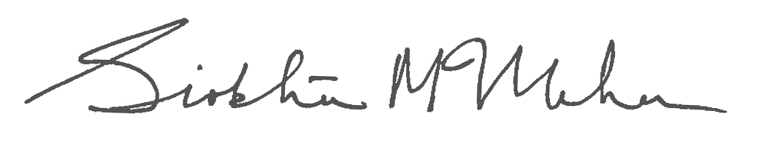

Siobhán McMahon, CAE
Chief Operations Officer
ASBO International

